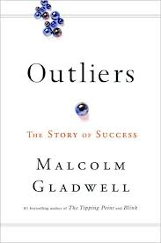
Outliers Reading Schedule
Chapters to Read | Due Date for Reading
Introduction (p. 3-11) and Start Chapter 1 (p. 15-34)  Finish Chapter 1 on your own | Thursday, 3/26 (Start reading book together via video conference)
Chapter 2 (p. 35-68) | Friday, 3/27 (Read on your own)
Chapter 3 (p. 69-90) & Chapter 4 (p. 91-115) | Tuesday, 3/31 (discuss chapters 2-4 via video conference)
The dates below are pending further information about when we will return.
Chapter 6 (p. 162 – 176) | Wednesday, 4/1 (Read on your own)
Drafting Practice Rhetorical Analysis Paragraphs | Thursday, 4/2 & Friday, 4/3
Chapter 7 (p.177-223) | Friday, 4/3 (discuss chapters 6-7 via video conference)
Chapter 8 (p. 224-249) | Monday, 4/13 (Read on your own)
Chapters 9 (p. 250-269) | Tuesday, 4/14 (Read on your own)
Epilogue (p.270-285) | Wednesday, 4/15 (discuss 8, 9, & epilogue via video conference)
Reading Outliers:
- Outliers is a nonfiction book.
- You will need to read this book in a slightly different way than you are used to.
- I will post study questions for each chapter – it is up to you whether you do these questions or how you use them. I will not collect them.
- As you read each chapter, look for:
  - main ideas (his claims)
  - supporting evidence (his evidence)
  - explicit and implicit message (his interpretation)
  - ethos, pathos, logos (how he uses rhetoric)

